Learning Journal

# Links to other submissions

Tutorial 1 - [Tutorial 1 - Character Controller](https://docs.google.com/document/d/1kXKuI7xhmBIXM3oiO8_JaJC-cx85Y3c3AGJwst4gOUk/edit?usp=sharing)

Tutorial 2 - [Tutorial 2 - Creating an enemy](https://docs.google.com/document/d/14LQrtnk-cNpL4J4aDBai96Y-aY1egN7l94b-lfhQuAQ/edit?usp=sharing)

Tutorial 3 - [Tutorial 3 - Sprint and Stamina system](https://docs.google.com/document/d/1nv88en7rssNrFeDrNjEycT7FkoGW7ceX19ziwrwUNSU/edit?usp=sharing)

Tutorial 4 - [Tutorial 4 - Dash](https://docs.google.com/document/d/160n0E_Tu_gQ_xxqEOH6dgpCf0wicgvz4-lFUmzZCWT4/edit?usp=sharing)

Playthrough - [Justin Briggs Game Development Mechanics Explanation.mp4](https://drive.google.com/file/d/1Slw_y-HJz91aRJW1adaM8pgApEln4q_t/view?usp=sharing)

Source files - [Source file](https://drive.google.com/file/d/1flIKz9pqjZV5l1w3NzzSRTHMmO5Gl5qe/view?usp=sharing)

# Explanation of why there are too little logs

There are only two date logs for this work because I only did the programming on two days. I did the most important and longest part on the 17th October 2023, and the rest was done December 14th 2023. The reason I did it this way is because I get hyper fixated whenever I start a task and feel a compulsive need to finish it. I ended up spending 3 hours straight on 17th October for the character controller then around 7 more hours in December creating the rest of the mechanics used in the prototype game. I was going to make even more mechanics before my peers online began telling me I didn’t need to do so much as I only had to explain four of them and creating five/six mechanics was more than enough.

I did want to do more but I would’ve had a hard time explaining how to do them without giving the code outright.

The mechanics I did create are ones I’ve created in other engines but never unity and are vital for almost any game out there so it was important that I had to learn how to do them in preparation for my year 3 modules.

# 17/10/23

Today was the day I created the character controller, the hardest part of the game. Its purpose is to allow the user to control a player model inside the game and interact with everything inside of the game. I had to follow a guide [] to learn about the inputs as that was something I had no idea how to do in Unity. The guide also helped me learn Camera controlling which I also had no idea how to do. Overall I would say creating this is a must for every single person who ever wants to work with unity as there is no other mechanic in a game that is more important than a user being able to interact with the game itself.

Due to having a guide to follow, there were no issues creating the character controller except for one part: the jump. After creating the character script and testing it I realized the user’s jump was a different height almost every time and sometimes I would rocket into space. This is when I knew the Jump function was running multiple times if the user held down the space bar. The way I combatted this bug was to create a new boolean named readyToJump and make sure that it reset only when the next frame that space bar wasn’t pressed happened. This solved the problem almost immediately and allowed me to create my double jump mechanic very easily.

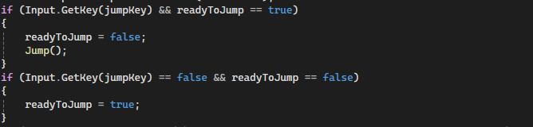

# 14/12/23

Today I created 3 more mechanics for my game: the enemy, the sprint and stamina system, and the dash. I did not use any public guides for these mechanics and solely used unity’s official documentation page for everything I needed.

For starters, the dash was very simple to make. Due to already facing a problem with multi inputs in October, I knew how to deal with it. I created a similar pair of conditions to that and the actual “dash force” was just firing a rigidbody’s addforce with the direction of the player’s transform.forward.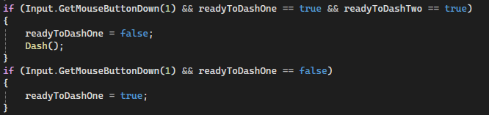

Next is the sprint and stamina system. This actually caused me a few problems related to the logic behind how each frame processes the inputs. I originally had the sprint and recharge functions be recursive (they run themselves) to create a sustainable loop until the stamina was either drained or full. However, I didn’t realize that the sprint and recharge functions actually ran every single frame so it would cause a lot of performance issues and would also instantly drain stamina and instantly recharge it too. It also caused the player’s speed to not be reset back to 5 because it was looping the sprint script while still recharging.

To fix this I removed the recursive loops so that each function would only run once per frame and that solved a majority of the problems but the other problem was that the player could sprint while recharging and it would be infinite. The easy fix for this was to change the conditions in the FixedUpdate script so that “recharging” was the dominant boolean to determine whether a player could sprint or not. If the recharging value was false the player was completely unable to sprint and that solved it.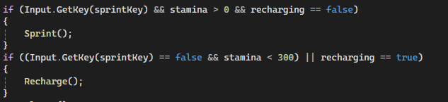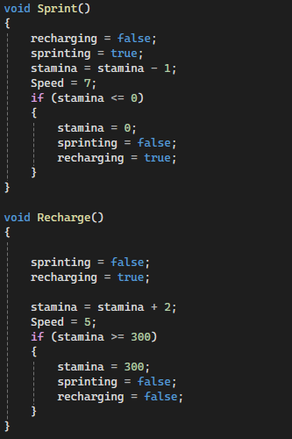

Lastly is the enemy script, something I made in the first year but only on a 2D plane and I had forgotten a lot of the logic behind it. I already knew the logic behind (endposition - startposition) and unit vectors and transforms so that wasn’t a difficult part. The actual hardest part of the code was the creation of the bullet as Quaternions are much more complicated than unity leads on.

The bullet would always be rotated in a weird angle so I had to use the unity official documentation to look for ways to rotate an object and discovered transform.lookAt. This fully fixed the weird rotation of the bullets.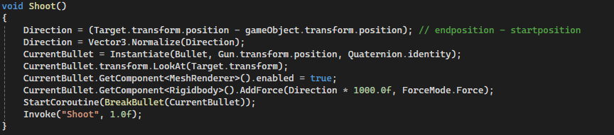

A lot of my code works on the first try because I re-read it multiple times before testing. I do this to save time in debugging as I can read much faster than my pc can load the world and test the mechanic. This is why I say there weren’t many problems with my code.

# More I wish to do next time

It was a given I did not do as much as I would’ve hoped to with this project. I had plans to create a full obstacle course map with swinging mechanics too but I wanted to keep it simple for the tutorials if these are ever shared. I also want to also be more aware of issues with my submissions as I had no idea all of my submissions in semester 1 had their permissions reset with google for no reason. I even fixed it and it still turned out to be a problem but it should be fixed now.